**Communi-KT**

The Next-Generation of Social Media in the Metaverse

**Introduction.**

In an ever-evolving digital landscape, where technology is reshaping the way we connect and interact, a groundbreaking social media platform emerges to revolutionize our online social experiences. Welcome to **Coummuni-KT**, a transformative new social media platform that harnesses the power of the metaverse to create a virtual realm where people can connect, collaborate, and explore like never before.

Communi-KT brings together the concepts of social media and the metaverse, combining the vast possibilities of virtual reality, augmented reality, and immersive technologies to create a seamless and immersive digital environment. It offers users a new dimension of connectivity that transcends physical boundaries, allowing individuals to interact and engage with each other in ways that were previously unimaginable.

At the core of Communi-KT is the belief that social media should be a place where people can authentically express themselves and build meaningful connections. Users will be able to create personalized avatars that accurately represent their unique identities and navigate a diverse array of virtual spaces within the metaverse. Whether it’s exploring bustling virtual cities, serene natural landscapes, or themed communities, Communi-KT provides a dynamic and customizable environment for users to connect with friends, meet new people, and engage in shared interests.

One of the Communi-KT’s key features is its emphasis on community-driven experiences. Users will have the ability to create and join virtual communities centered around various topics, hobbies, and passions. These communities will serve as hubs for like-minded individuals to come together, collaborate, and share their experiences. Whether it’s a photography club, a music collective, or gaming guild, Communi-KT empowers users to build vibrant communities that foster creativity, learning, and social engagement.

Communi-KT also recognizes the importance of real-world integration. Through augmented reality features, users will be able to seamlessly bridge the gap between the virtual and physical worlds. From virtual meetups and events to interactive advertising campaigns, Communi-KT opens up endless possibilities for businesses, creators, and individuals to connect with their audience in innovative and immersive ways.

Furthermore, Communi-KT prioritizes user privacy and security, ensuring that individuals have control over their personal data and the ability to curate their virtual experiences. With robust moderation tools and strong commitment to combining harassment and harmful behavior, Communi-KT aims to cultivate a safe and inclusive environment for all users.

In summary, Communi-KT represents a paradigm shift in the world of social media, leveraging the metaverse to create an immersive and interconnected digital realm. With its emphasis on authentic self-expression, community-driven experiences, real-world integration, and user privacy, Communi-KT is poised to redefine the way we connect, collaborate, and share in the digital age. Get ready to embark on a journey into the metaverse and experience social media like never before with Communi-KT.

**What exactly this is and what to expect?**

Communi-KT is a novel social media platform that leverages the concept of the metaverse to offer users an immersive and interconnected digital experience. Here’s what you can expect from Communi-KT:

1. Metaverse Integration
2. 2D for most needed functionalities and 3D support for world interaction in, most likely, VR.
3. Personalized Avatars
4. Virtual Spaces and Communities: individual property -> groups -> neighborhoods -> cities.
5. New shopping experiences
6. Collaborative experiences for co-working
7. Privacy and Security
8. Innovative adverting and Brand engagement
9. 3rd party support on plugins integrations. Most likely to add personalized functionalities and environments and Eshops; with privacy, security and system’s integrity put as higher priority.

Overall, Communi-KT represents a convergence of social media and the metaverse, offering users a dynamic and interconnected digital environment where they can express themselves, build meaningful connections, explore virtual spaces, and collaborate on creative projects. It aims to redefine the way we interact each other online, providing a glimpse into the exciting possibilities that the future of social media holds.

**Processes diagram.**

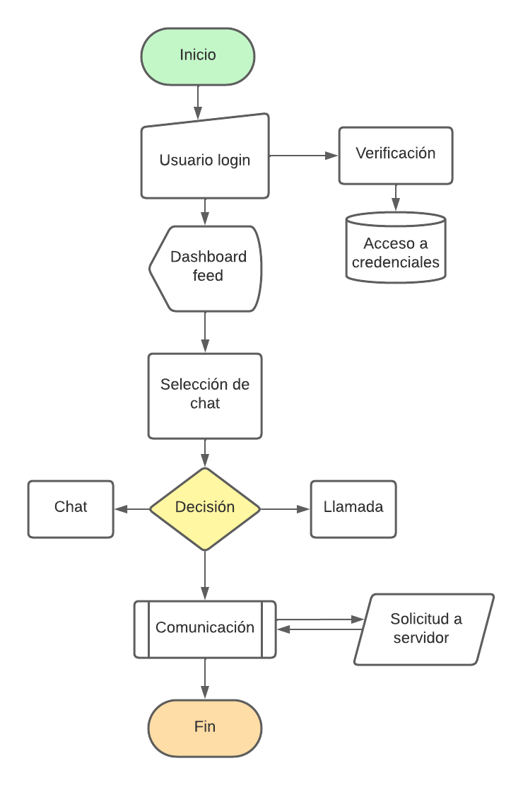

**Interface.**

The following picture illustrates the possible final logo for the social media. It represents the world with the sphere, and the human interconnection with the illustrative net upon the planet.

Key features for the message given are:

* People, us, community.
* Planet, world.
* Net, connection.

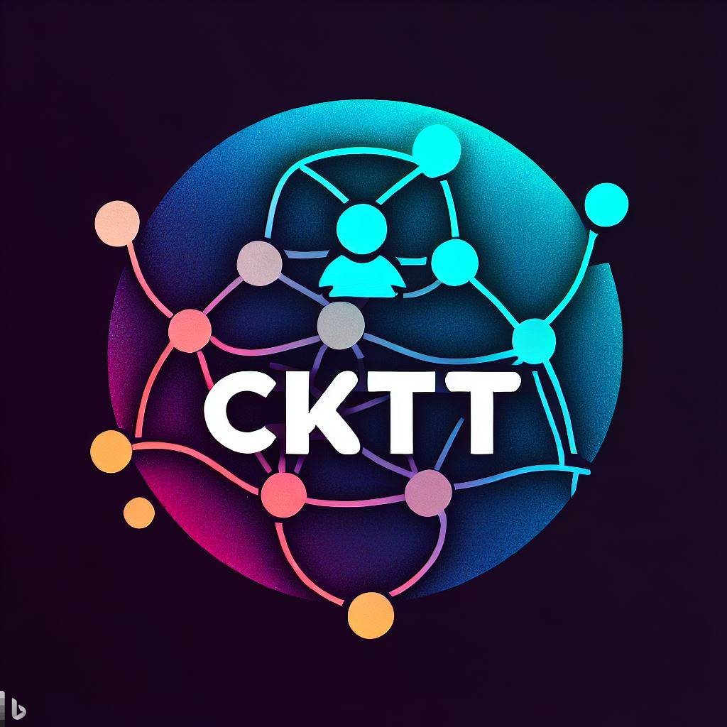

**Functional requirements.**

* Distributed Database for working.
* 3rd parties’ interface for shops, boutiques, healthcare, and services interaction.
* Allow chats between users: Image, Video, Audio and Files.
* 2D and 3D support.
* Collaborative features for co-working.

**Non-functional requirements.**

* Run on Android.
* Run on iOS and iPad.
* Web app for desktop.
* ReactJS for frontend web app development.
* Backend written in Python.

**Resources.**

Effective resource management is a cornerstone of success.

*Chores Management and time management:*

This platform was designed to be fully covered in 8 modules in total: four on frontend and 4 more on backend.

Those modules can be tracked and manages throughout their lifecycle to ensure that they are properly configured, controlled, and maintained.

Within this document we consider two main parts for our communication system:

* Frontend
  + GUI’s design.
  + Multiplatform support for multiple devices: Web, iOS and Android.
  + 2D and 3D realms (user can choose whether to access to trivial interface or access to their own world).
* Backend
  + Database for storage all the information, in the essence of the DB Management software as well as the design.
  + Encryption of the user’s information
  + Data analysis of user’s behavior.
  + 3rd party integration for e-shops, healthcare, and services.

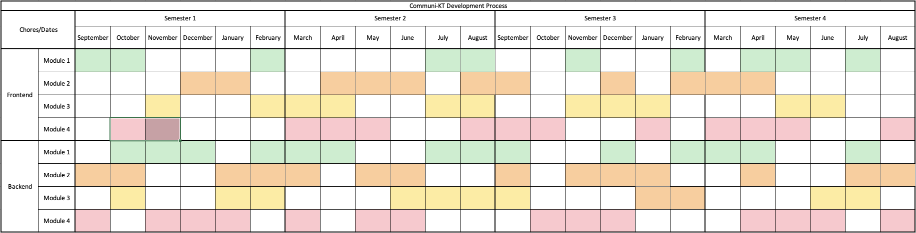

*Budget Management:*

The total budget needed to successfully complete this project is estimated to be: **$112,000 USD**. This budget totally covers all the functional and not functional requirements.

*Risk scale and analysis*:

With this proactive process we’ll guide ourselves understand and manage the uncertainties we could face. Represents a fundamental component of good governance, strategic planning, and overall business success.

In this specific project, we’ll use it for:

* Identification of Potential Threats.
* Prioritization of risks.
* Recourse allocation.
* Decision making.
* Compliance.
* Cost saving.
* Long-term sustainability.

*Effort analysis*:

This effort analysis for Communi-KT involves estimating the resources, time, and costs required to develop, launch, and maintain the platform. Here’s a simplified effort analysis:

1. Development phase.
   * Development team:
   * Equipment
   * Timeframe.
   * Cost
2. Content moderation and management.
   * Moderation team
   * IA Tools
   * Equipment
   * Timeframe.
   * Cost.
3. Security and privacy.
   * Security team
   * Privacy compliance
   * Equipment
   * Timeframe
   * Cost
4. User engagement and support.
   * Community managers
   * Support team
   * Equipment
   * Timeframe
   * Cost
5. Monetization strategy.
   * Marketing team
   * Equipment
   * Timeframe
   * Cost
6. Maintenance.
   * Team
   * Equipment
   * Timeframe
   * Cost

*Priority scale and analysis:*